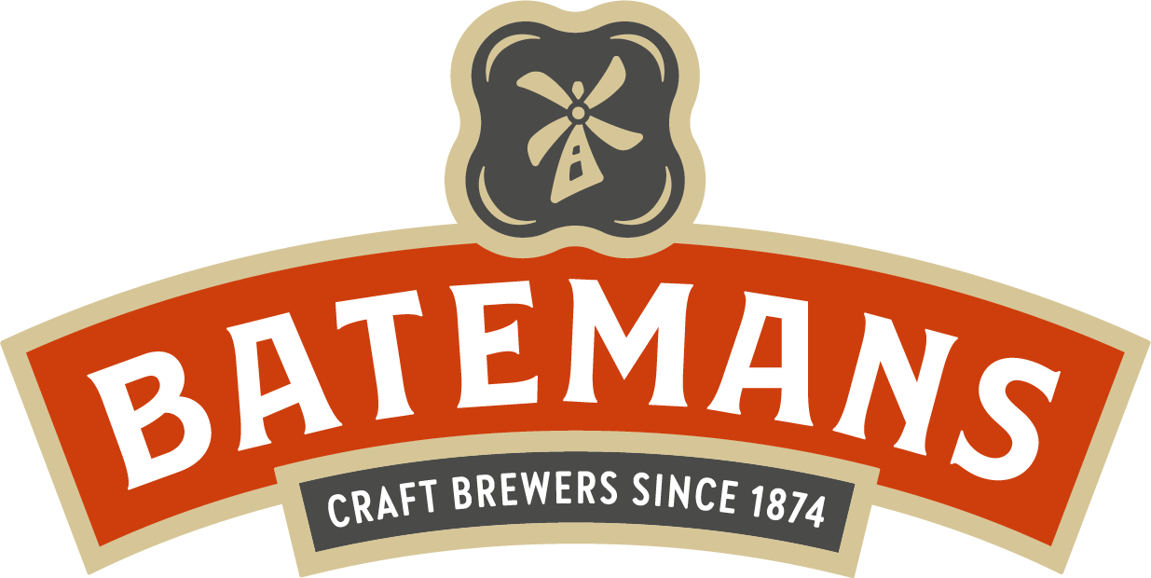
George Bateman & Son Ltd Salem Bridge Brewery, Wainfleet, Skegness, Lincolnshire PE24 4JE

PUBLIC HOUSE APPLICATION
Applicant’s Name | Specific Pub Interest  (If general enquiry, please state)

The information you give on this form will be treated as STRICTLY CONFIDENTIAL. No approach will be made to your present employer without your consent. Please complete the form in INK using BLOCK CAPITALS. This application will be kept on file and remain valid for a period of one year.
 | Applicant | Partner
Surname
Forename(s)
Maiden Name (If applicable)
Nationality
Marital Status
Place of Birth
Children (Age)
Name and relationship of any person who would be living with you if successful
National Insurance Number
Present Address
How long have you resided at the present address?
If less than 6 months, please give previous address
Telephone No (Home)
Telephone No (Work)
Email Address

If yes, please give details
Name and address of any relative who is employed by Batemans or is one of our tenants
Is it convenient to contact you at work?

Have you ever made a previous application to Batemans Brewery?

Yes
No
Yes
No

EMPLOYMENT HISTORY

Please list all employment (commencing with your present job). Attach CV if more appropriate.

APPLICANT

Name & Address of Employer | Position Held | Date |  | Brief Details of Responsibilities
Name & Address of Employer | Position Held | From | To | Brief Details of Responsibilities

PARTNER
Name & Address of Employer | Position Held | Date |  | Brief Details of Responsibilities
Name & Address of Employer | Position Held | From | To | Brief Details of Responsibilities

QUALIFICATIONS AND EXPERIENCE
State details of your licensed trade/catering qualifications. Also details of training courses attended.
Do you hold a personal licence?

Yes

No
If yes, state Licence Number

Issuing Licence Authority

APPLICANT
Name of Course | Name of Location Course Held | Date |  | Qualification Obtained
Name of Course | Name of Location Course Held | From | To | Qualification Obtained
Do you hold a basic food hygiene certificate?

Yes
No

PARTNER
Name of Course | Name of Location Course Held | Date |  | Qualification Obtained
Name of Course | Name of Location Course Held | From | To | Qualification Obtained
Do you hold a basic food hygiene certificate?

Yes
No

FINANCE/FINANCIAL DETAILS
Please give details of finacial sources
Existing Salary
Name and Address of Banker
Cash/Building Society/Bank
Net Proceeds of House Sale
Net Sale of Business
Loan from Bank/Other
Pension/Other Income
Total

REFERENCES
Please give two names and addresses for both applicant and partner

 | Applicant | Partner
Name
Occupation
Address
Telephone Number
Email

Name
Occupation
Address
Telephone Number
Email

Please note – These references will not be sought without your permission.

Public House Type

Tick boxes for pub type and location

Geographical area of interest
AVAILABILITY

Can you take up occupation:
Immediately
Within 3 months
Other? (Please specifiy)
Type of pub Tick areas of interest

Community
Food

Cask Led
Village
Town

DECLARATION
Should you feel you wish to give further details regarding yourself or your intentions, please send with this application form.

I declare that the information provided on this form is correct in every aspect and that I have not withheld any material facts. If any information given is incorrect or any material facts withheld, I acknowledge that George Bateman & Son Ltd reserve the right to withdraw any offer that may have been made.

Signature

Applicant ………………………………………… Date ……………………………

Partner ………………………………………….... Date …………………………...

Thank you for completing this form. Please check that you have included all relevant details.
Send your completed form to the address on the front of the application.
OFFICE USE ONLY Acknowledged:
Received: Recommendation:

Interview By: Date:

Telephone: (01754) 882011 – Email: fcarville@bateman.co.uk - Web: www.bateman.co.uk

